Inventory Syncing Data/Work Flow
Inventory Syncing Data/Work Flow
1. OGL => Magento
First Product Stocks get updated in ProfitPlus Dashboard(ERP). That data is synced in Magento via custom cron.
Cron frequency is set to every 45 minutes.
There is a cli command that is set in cron execution.
Command executes on cron execution: ogl:product:stock
The extension/module executing this command logic : ogl/module-eshop-stock
Logging system : eshop3.cron.log (/home/datapower)
Data syncing pattern: Inventory gets synced based on warehouse.

2. Magento => Amazon
There are two crons running for Amazon Stock syncing. The mechanism is based on the queue.
The data get in queue first based on the same amazon integration variables.
AccountID,ProfileID and catalog listing assigned to ProfileID.
Cron responsible to sync data and put it in queue: AllInventorySync (Every 30 minutes)
After data get in queue second cron run which is responsible to push data to amazon through API
Cron responsible get queued data and push in amazon: Inventory Queue Sync (Every 5 minutes)
Logging system: Logs request in db table ( amazon_api_change_log)

OGL Admin

OGL Product Import Data

Import Products

Admin -> ESHOP3->Products->Product Import

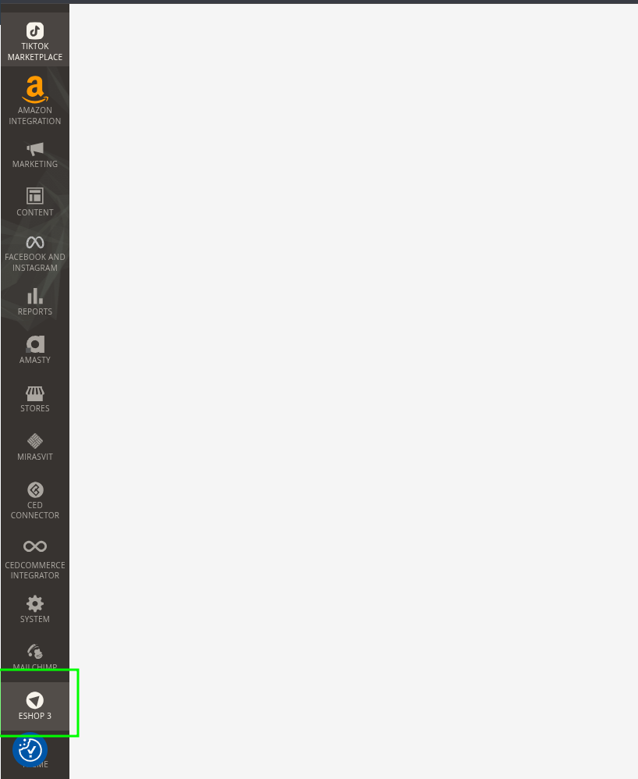

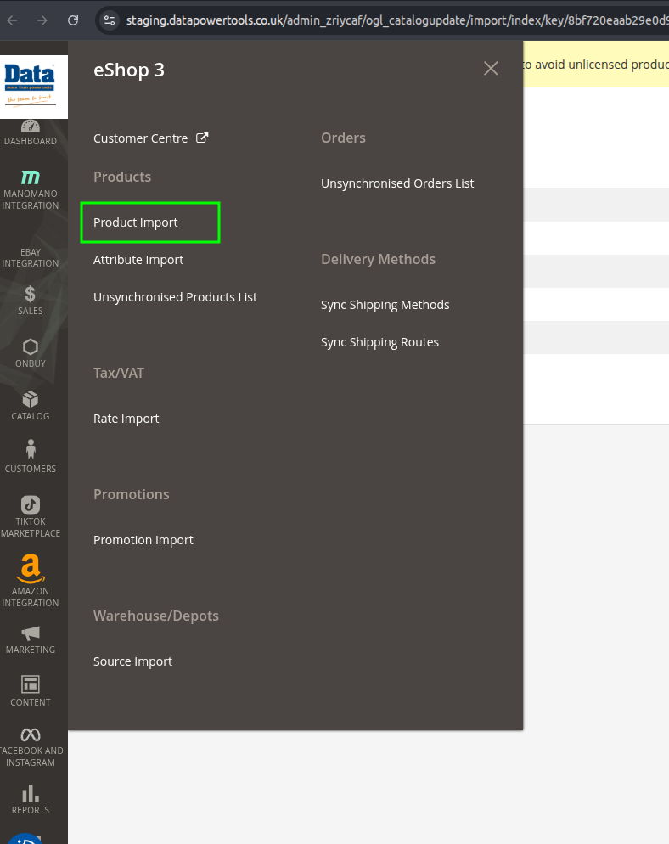

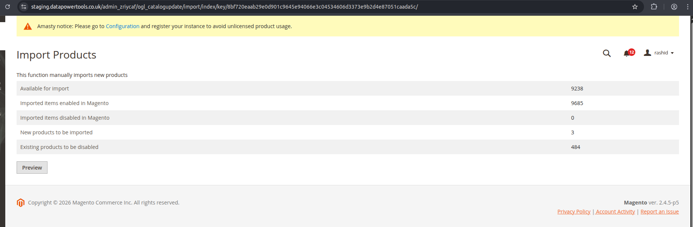

Source Import

Admin -> ESHOP3->Warehouse/Depots->Source Import


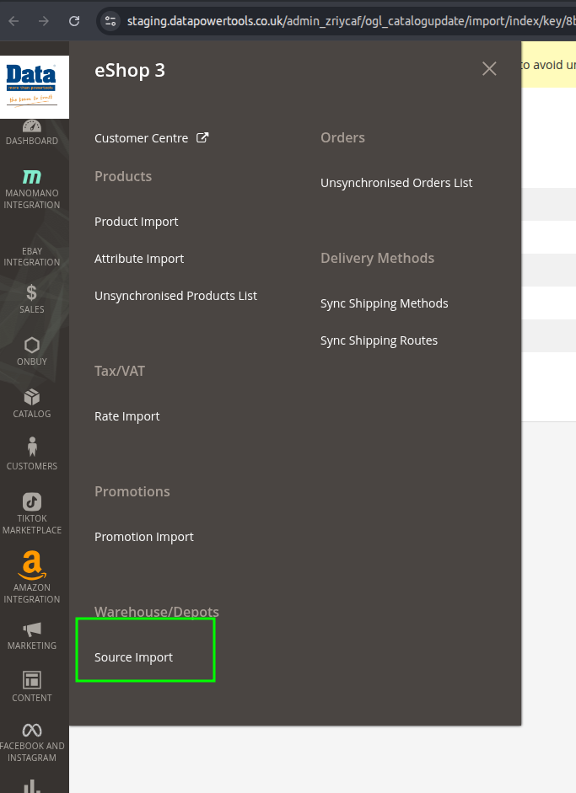
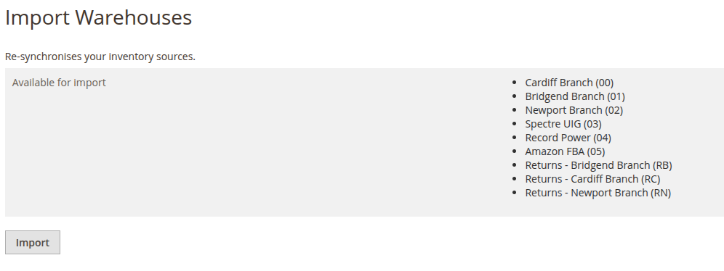

Amazon Admin

Amazon Account Data and config

Amazon Inventory Config:

Admin -> Store -> Settings -> Configuration
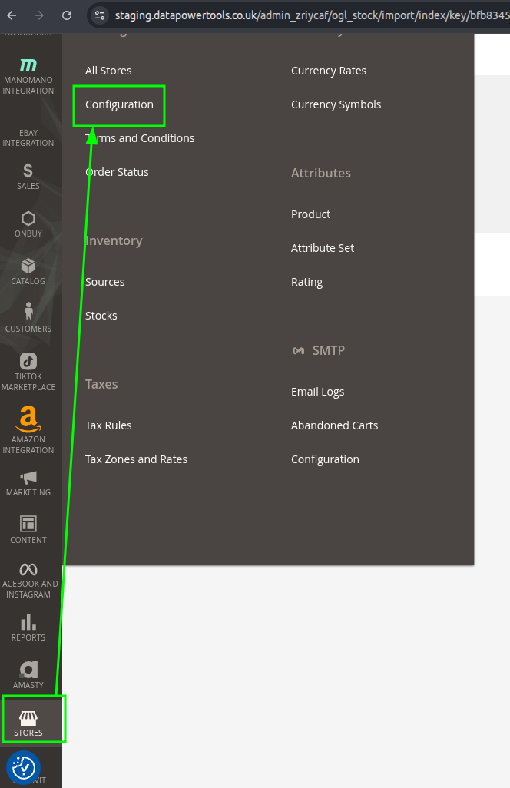

Inside configuration
CEDCommerce->Amazon Configuration

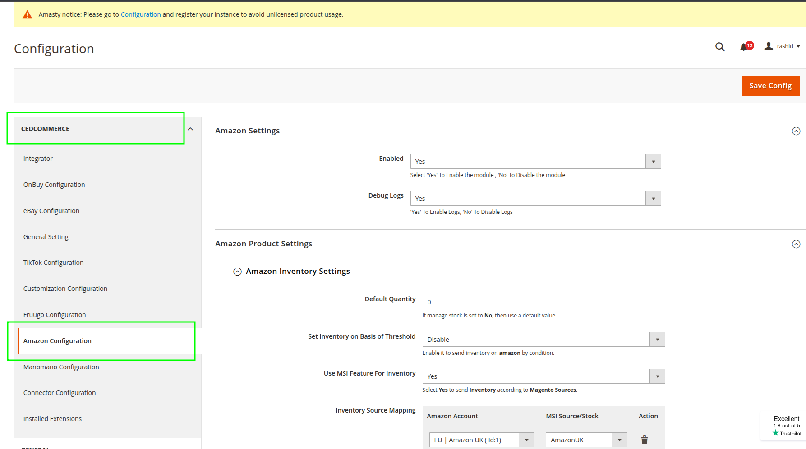

Amazon Inventory Settings:

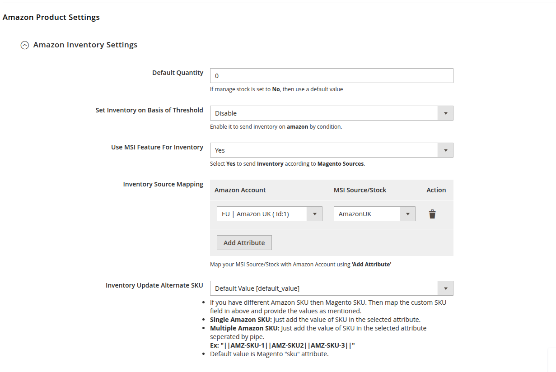

Amazon Cron Settings:
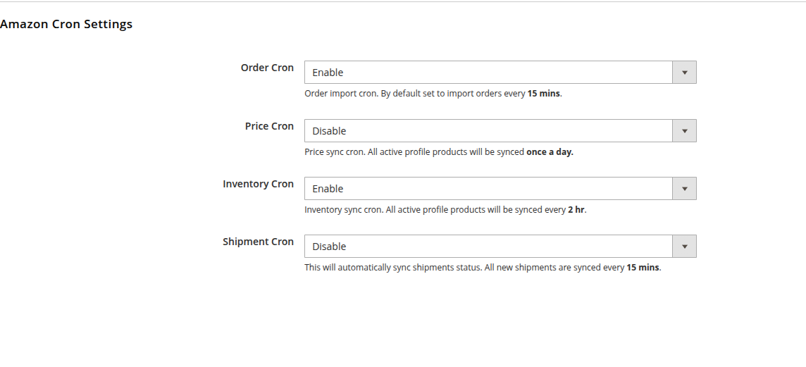

Amazon Account dashboard

Admin Amazon Integration Dashboard

Admin -> Amazon Integration

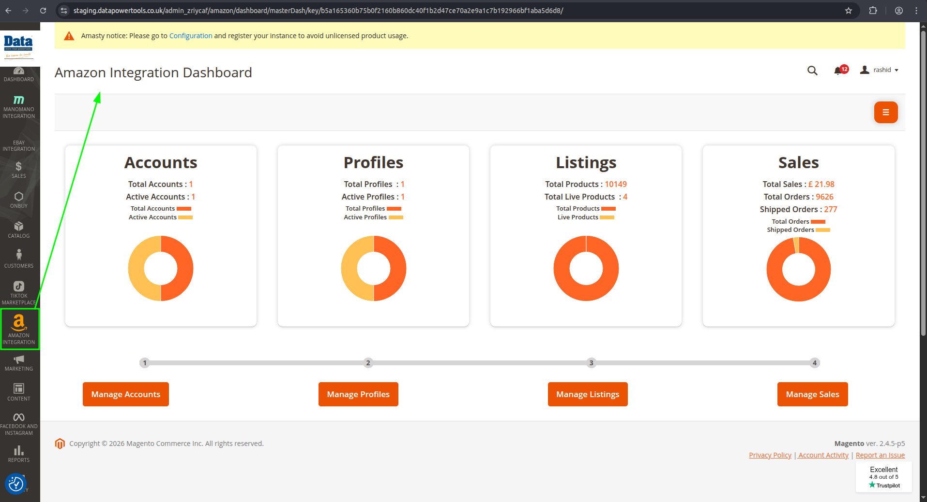

Manage Account: Amazon integration account

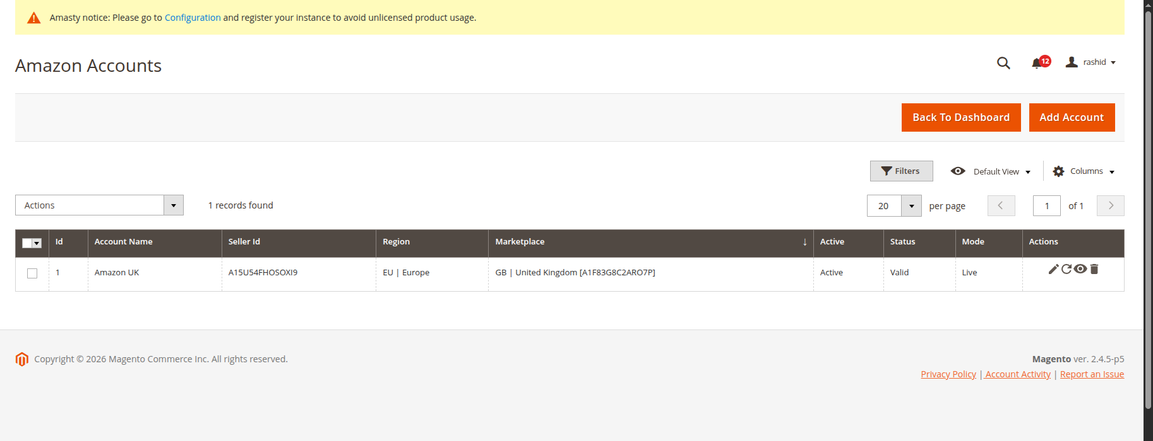
Manage Profile: Account’s profile

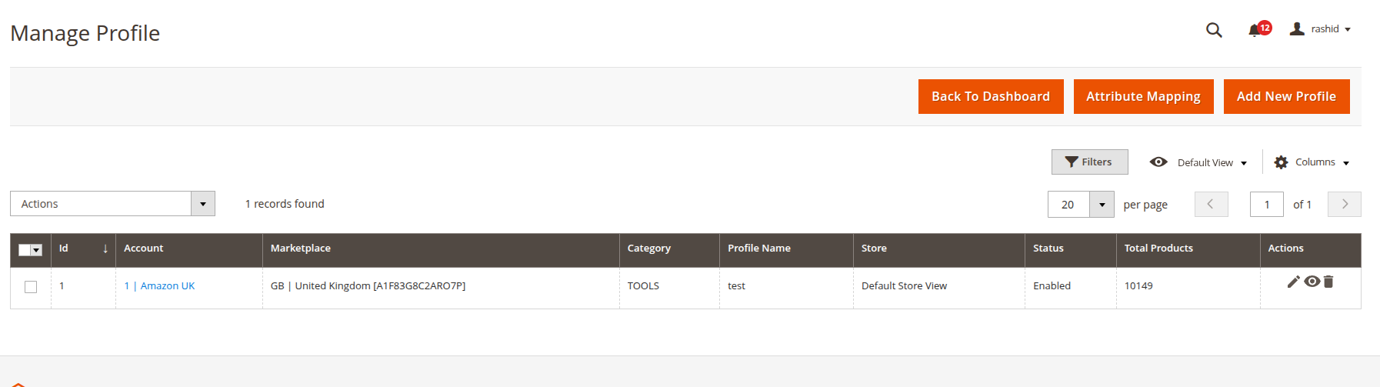

Manage Listing : Product listing of synced products (we can check inventory here)
Note: edit/view of product redirect to magento’s product view.
